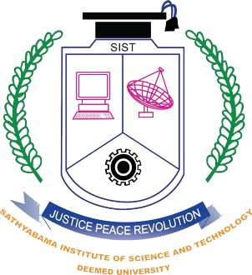

SATHYABAMA INSTITUTE OF SCIENCE AND TECHNOLOGY

FEES
S.NO | CATEGORY | AMOUNT IN RS.
1 | Tuition Fees | waived
2 | Book fees, Exam fees and processing fee | INR. 15,000
3 | Food | INR. 40,000/semester
4 | Hostel
 | Standard rooms - Sharing without AC | INR. 30,000/semester
 | AC rooms - Sharing with AC | INR 50,000/semester
5 | Total Fees
 | With Standard Room | INR. 85,000 / semester
 | With AC Rooms | INR. 105000 / semester

