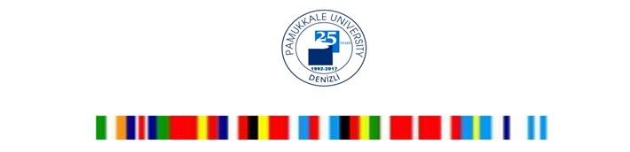

THE 7th INTERNATIONAL WEEK

8 -12 May 2017

PAMUKKALE UNIVERSITY, DENIZLI

TURKEY

We are inviting all our academic and administrative colleagues from our Partner Institutions to share working experiences and best practices during this event.

Working Language : English

All travel costs, some meals and accommodation have to be covered by the participants (e.g. by Erasmus+ program). Pamukkale University will cover social-cultural activity programmes during the week.
We hope to see you in Pamukkale University, Denizli TR.

Assoc. Prof. Dr. Zeha YAKAR
International Relations Coordinator

To see Application form
http://www.pau.edu.tr/uluslararasi/en/sayfa/the-6th-international-week
Visit our website to see our last year events and photos
http://www.pau.edu.tr/uluslararasi/en/sayfa/the-fourth-international-week-2014
http://www.pau.edu.tr/uluslararasi/en/sayfa/the-third-international-week-2013

For more information and application form please contact
Miss. Sevgi ALTAYLI, E-mail: internationaloffice@pau.edu.tr

FAX: +90 258 296 2343

Application deadline
31 March, 2017

